**CRM QUERY**

1. **ERD diagram**

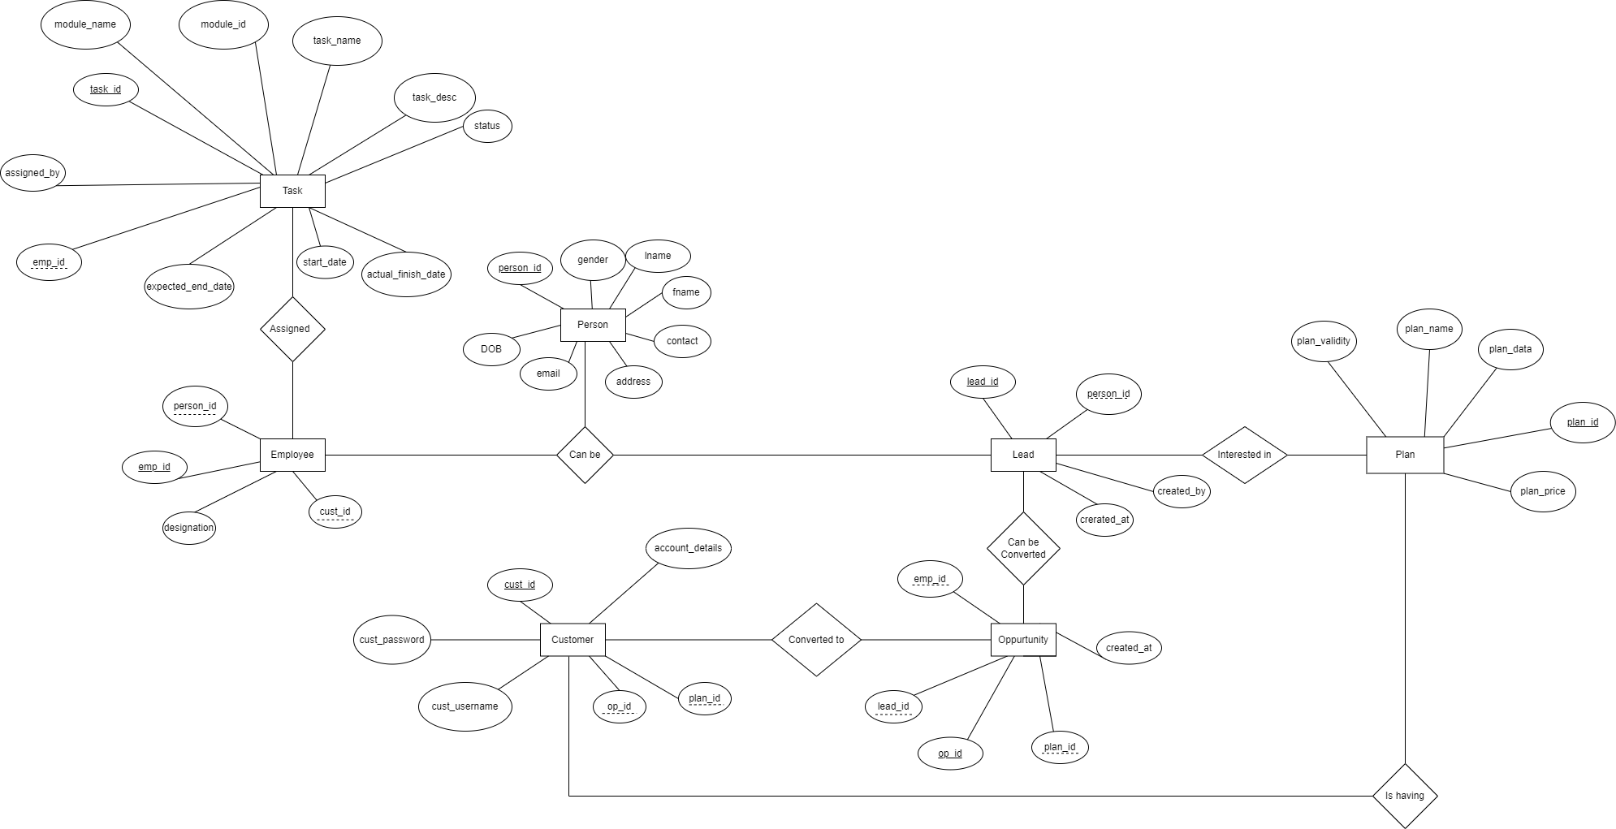

1. **Create Normalized Tables, Create database CRM and create tables , create Indexing, Use PK, FK, UK**

create table person(

person_id int primary key,

first_name varchar(25) not null,

last_name varchar(25) not null,

gender char(1) not null,

date_of_birth date,

email varchar(32),

contact_no bigint not null,

address varchar(35)

);

create table lead(

lead_id int primary key,

created_at date not null,

person_id int references person(person_id)

);

create table plan(

plan_id int primary key,

plan_name varchar(20) not null,

plan_validity varchar(30) not null,

plan_data varchar(20) not null,

plan_price char(15) not null

);

create table opportunity(

opportunity_id int primary key,

created_at date not null,

emp_id int ,

lead_id int references lead(lead_id),

plan_id int references plan(plan_id)

);

create table customer(

customer_id int primary key,

cust_username varchar(25) not null,

cust_password varchar(25) not null,

ac_details varchar(20) not null,

opportunity_id int references opportunity(opportunity_id),

plan_id int references plan(plan_id)

);

create table employee(

emp_id int primary key,

designation varchar(30) not null,

person_id int references person(person_id),

customer_id int references customer(customer_id)

);

create table task(

task_id int primary key,

task_name varchar(25) not null,

task_desc varchar(25) not null,

task_status varchar(20) not null,

start_date date,

expected_end_date date,

actual_end_date date,

assigned_by varchar(25) not null,

module_id int not null,

module_name varchar(20),

emp_id int references employee(emp_id)

);

select * from person;

select * from lead;

select * from plan;

select * from opportunity;

select * from customer;

select * from employee;

select * from task;

1. **Use Limit, Aggregrate Function, Joins, Use views , Query to Insert minimum 50 records lead the table.**

INSERT INTO PERSON

insert into person values( 1, 'Sumant' , 'mulgaonkar', 'M', '2000-01-20','sumant@gmail.com', 9998388383 , 'Goa') ;

insert into person values( 2, 'Sameer' , 'Shaikh', 'M', '1991-11-15','sameer@gmail.com', 7263472827 , 'solapur') ;

insert into person values( 3, 'Mandar' , 'joshi', 'M', '1999-01-11','mandar@gmail.com', 9483657465 , 'tamil nadu') ;

insert into person values( 4, 'Suresh' , 'suthar', 'M', '1994-04-20','suresh@gmail.com', 8364536453 , 'rajasthan') ;

insert into person values( 5, 'Prajakta' , 'kelkar', 'F', '1999-01-05','prajakta@gmail.com', 9283746564 , 'pune') ;

insert into person values( 6, 'Pranath' , 'naik', 'M', '1999-08-10','pranath@gmail.com', 9998388386 , 'arambol') ;

insert into person values( 7, 'Sayali' , 'tamane', 'F', '1993-01-20','sayali@gmail.com', 9287374658 , 'nagpur') ;

insert into person values( 8, 'Aman' , 'kumar', 'M', '1997-02-22','aman@gmail.com', 9283745345 , 'bihar') ;

insert into person values( 9, 'Brinda' , 'chanchad', 'F', '2000-07-25','brinda@gmail.com', 9283745231 , 'gujrat') ;

insert into person values( 10, 'Shubangi' , 'pangare', 'F', '2002-12-31','shubangi@gmail.com', 9998128838 , 'pune') ;

INSERT INTO LEAD

insert into lead values (1,'2021-10-31', 3 );

insert into lead values (2,'2021-11-15', 4 );

insert into lead values (3,'2021-09-17', 5 );

insert into lead values (4,'2021-08-09', 6 );

insert into lead values (5,'2021-12-3', 7 );

insert into lead values (6,'2021-07-22', 8 );

INSERT INTO PLAN

insert into plan values(1, '50Mbps', '1 month', '180GB' , 399 );

insert into plan values(2, '100Mbps', '3 months', 'unlimited' , 399 );

insert into plan values(3, '20Mbps', '6 months', '900GB' , 699 );

insert into plan values(4, '200Mbps', '12 month', '12180GB' , 15999 );

insert into plan values(5, '150Mbps', '9 month', '6000GB' , 9999 );

INSERT INTO OPPORTUNITY

insert into opportunity values (1, '2021-09-20', 3, 2);

insert into opportunity values (2, '2021-08-15', 4, 1);

insert into opportunity values (3, '2021-12-10', 5, 4);

insert into opportunity values (4, '2021-07-25', 6, 5);

INSERT INTO CUSTOMER

insert into customer values (1, 'sayali998' , '12345', '1102928182', 3, 4 );

insert into customer values (2, 'aman818' , '123456', '1102998828', 4, 5 );

INSERT INTO EMPLOYEE

insert into employee values(1, 'Asstt Officer', 1, 2);

insert into employee values(2, 'Engineer', 2, 1);

INSERT INTO TASK

insert into task values(1, 'Installation', 'Installing new broadband',

'completed', '2021-07-26' ,'2021-08-30','2021-09-01', 'admin1', 011, 'INSTALL', '1');

insert into task (task_id, task_name, task_desc, task_status, start_date, expected_end_date, assigned_by, module_id, module_name,emp_id )

values(2, 'Plan Change', 'Change Plan to 150 mbps',

'pending', '2021-12-13' ,'2021-12-20', 'admin2', 021, 'PLAN CHNAGE', '2');

**USING AGGREGATE**

* select count (*) from person where address ='pune';
* select count(plan_name) from plan;
* select max(plan_price) from plan where plan_data !='unlimited';
* select min(plan_price) from plan where plan_data !='unlimited';
* Select CONCAT(first_name, ' ', last_name) AS full_name from person;

1. **Query to get a list of all leads**

select * from lead;

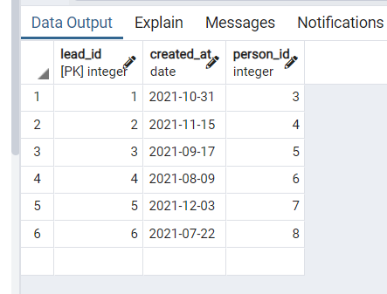

1. **Query to get all leads which converted to Opportunity**

Select lead.lead_id ,lead.created_at, lead.person_id, opportunity.opportunity_id, opportunity.plan_id

from lead

inner join opportunity on opportunity.lead_id =lead.lead_id ;

select le.lead_id ,le.created_at, le.person_id, opp.opportunity_id, opp.plan_id

from lead le

join opportunity opp on opp.lead_id =le.lead_id ;

select le.lead_id ,le.created_at, le.person_id, opp.opportunity_id, opp.plan_id

from lead le join opportunity opp using(lead_id) ;

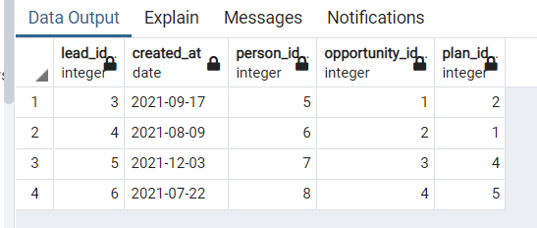

1. **Query to get all leads converted to Account**

select le.lead_id ,le.created_at, le.person_id, cus.customer_id, opp.opportunity_id

from lead le

join opportunity opp ON opp.lead_id = le.lead_id

join customer cus ON cus.opportunity_id = opp.opportunity_id;

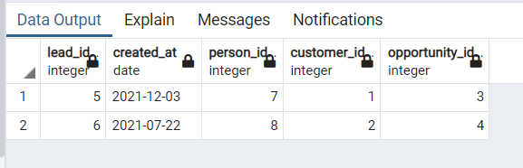

1. **Query to get All contacts of an Account**

select le.lead_id ,le.created_at, le.person_id, cus.customer_id, opp.opportunity_id

from lead le

join opportunity opp ON opp.lead_id = le.lead_id

join customer cus ON cus.opportunity_id = opp.opportunity_id;

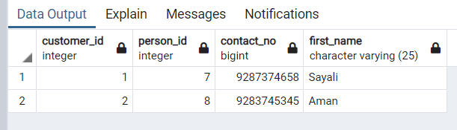

1. **Query to get the count of task Module wise**

select count(task_id) from task group by module_id;

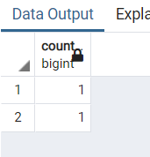

1. **Query to get All tasks of Leads, Opportunity, Account**

select * from task;

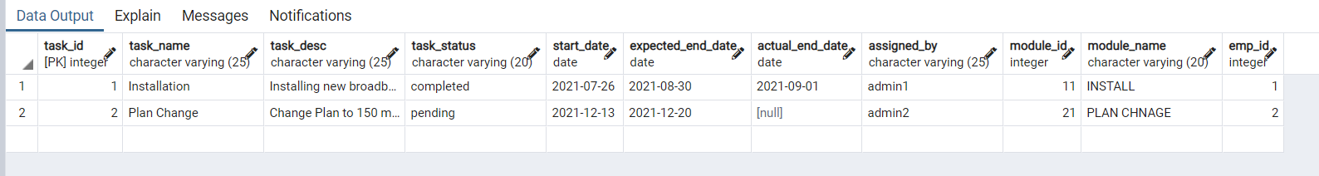

1. **Query to get all accounts that do not have contacts**

select cus.customer_id , pe.person_id, pe.contact_no, pe.first_name

from customer cus

join opportunity opp ON opp.opportunity_id = cus.opportunity_id

join lead le ON le.lead_id = opp.lead_id

join person pe ON pe.person_id= le.person_id

where pe.contact_no = 0;

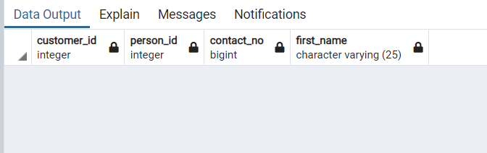

1. **Query to get all task which is not created today.**

select * from task where start_date != current_date;

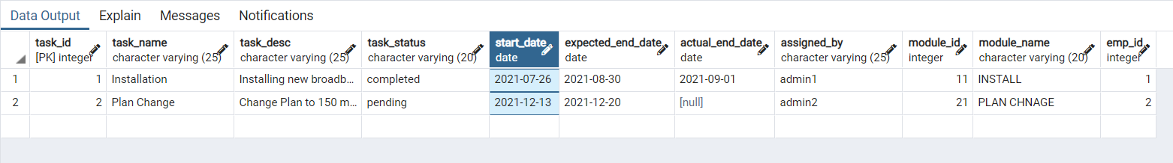

1. **Query to get all the task completed**

select * from task where task_status = 'completed';



1. **Query to get all upcoming tasks**

select * from task where start_date > current_date;

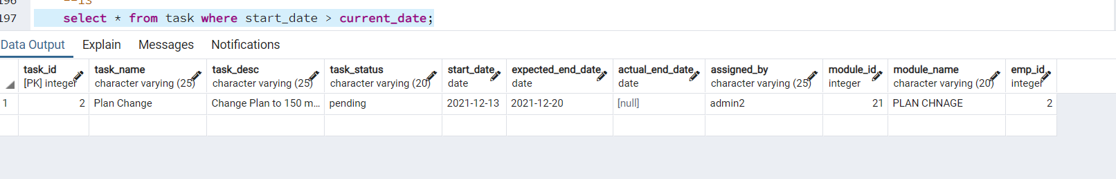

1. **Query to fetch account and its contacts with account id, account name**

select cus.customer_id , cus.ac_details, pe.contact_no, pe.first_name

from customer cus

join opportunity opp ON opp.opportunity_id = cus.opportunity_id

join lead le ON le.lead_id = opp.lead_id

join person pe ON pe.person_id= le.person_id;

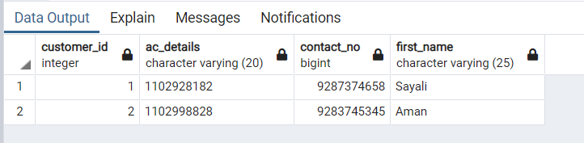

1. **Query to get the count of leads which is converted to account**

select count(le.lead_id)

from lead le

join opportunity opp ON opp.lead_id = le.lead_id

join customer cus ON cus.opportunity_id = opp.opportunity_id;

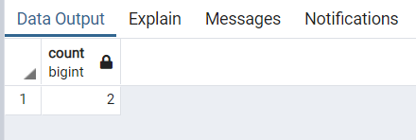

1. **Query to get all Opportunity**

select * from opportunity;

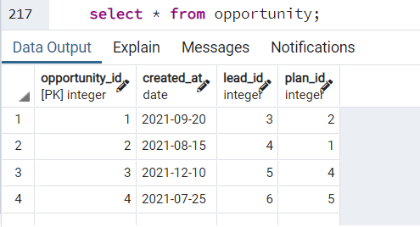

1. **Query to get all Opportunity which converted to Account**

select cus.customer_id, opp.opportunity_id, cus.cust_username

from opportunity opp

join customer cus ON cus.opportunity_id = opp.opportunity_id;

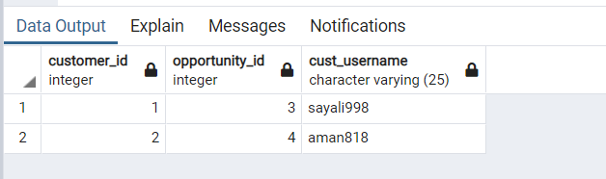

1. **Query to get count which plan is taken how many times**

select count(plan_id) from customer group by plan_id;

